Gypsy, Roma and Traveller Consortium Impact Report:
Health and Wellbeing Alliance 2018-2026
August 2026
The Gypsy, Roma and Traveller Consortium’s Impact Report: Health and Wellbeing Alliance 2018-2026

The Health and Wellbeing Alliance (HWA) is a network of national VCSE organisations that represent communities who share protected characteristics or experience health inequalities. The HWA work with NHS England (NHSE), Department of Health and Social Care (DHSC), and UK Health Security Agency (UKHSA) and the Office for Health Improvement and Disparities (OHID). The HWA facilitates integrated working between the statutory and voluntary sectors, support a two-way flow of information between communities, the VCSE sector and policy leads, amplifying the voice of the VCSE sector and people with lived experience to inform national policy. It aims to facilitate co-produced solutions to promote equality and reduce health inequalities.

The Gypsy, Roma and Traveller consortium is a HWA-based partnership between Friends, Families and Travellers and Roma Support Group:

Friends, Families and Travellers (FFT) is a national charity based in Brighton, working to end racism and discrimination against Gypsy, Roma, and Traveller people and to protect the right to pursue a nomadic way of life. FFT supports individuals and families with the issues that matter most to them, working at the same time to transform systems and institutions to address the root causes of inequalities faced by Gypsy, Roma and Traveller people.

Roma Support Group (RSG) is a Roma-led charity based in East London, working to improve the quality of life for Roma refugees and migrants by helping them to overcome prejudice, isolation, and vulnerability. Every year, RSG supports around 2,000 Roma people with access to welfare, health services including mental health, education, financial inclusion, campaigning and policy, housing and cultural activities.

Introduction
The Gypsy, Roma and Traveller consortium has been an active member of the HWA for the past ten years, working collaboratively to improve health outcomes for Gypsy, Roma and Traveller communities. The consortium has worked closely with system partners within UK Health Security Agency (UKHSA), Department of Health and Social Care (DHSC), Office Health Improvement and Disparities (OHID) and NHS England (NHSE). It has been committed to addressing health inequalities through a systems change approach, advocating at government level that the lived experiences of Gypsy, Roma and Traveller people need to be central to the design and delivery of health services through meaningful co-production and co-design.

Through this approach, the consortium seeks to address challenges such as data invisibility within health services, maternal health inequalities, digital exclusion, and barriers to accessing and maintaining engagement with health and wellbeing services.

The broad term ‘Gypsy, Roma and Traveller’ encompasses various distinct communities, and is often used to refer to people from Romany Gypsy, Irish Traveller, New Traveller, Liveaboard Boater, Showman and/or Roma backgrounds. The term ‘Romany Gypsy’ may also encompass English Gypsies, Scottish Gypsy/Travellers, Welsh Gypsies, and Romani people more widely.

These communities are sometimes compounded under the umbrella term ‘GRT’, and the use of this abbreviation presents similar issues to the use of ‘BAME’, as it arguably fails to reflect the true diversity of the communities referenced. For the purposes of this report, we have avoided its use. However, you may find the term used in other policy documents.

This report will use this broad definition of the Gypsy, Roma and Traveller communities, however, when necessary, it will refer to specific groups within these communities. When referring generally to the Gypsy, Roma and Traveller communities, this report uses the terms ‘community members’ or ‘Travellers’.

Co-production
The Gypsy, Roma and Traveller consortium have embedded FFT’s and RSG’s co-production policies and processes into all projects and reactive work we have completed within the HWA. This is to ensure the communities we work with steer the work we do and that any outputs —whether this be resources or research — are appropriate and resonate with Gypsy, Roma and Traveller communities.

An unintended consequence of this year’s HWA was that without a formal project, we were able to cement and refine FFT’s lived experience policies and practices. Through this, we ensured that payment guidelines were updated to reflect the cost of living; robust ethical safeguards and trauma informed practices are in place when engaging participants in steering groups, focus groups and interviews; and ensuring a diverse demographic spread for participation. It also gave space to sense test these principles with a community steering group to ensure that they were effective in reflecting people’s priorities and experiences in a way that felt meaningful and supportive to them. This year also enabled the co-design of other policies which sit in tandem with the lived experience policy, such as a guide for interviewers and focus group organisers on how to mitigate the risk of re-traumatisation. We’ve now embedded these refined practices and policies into our HWA work this year.

Community impact
Over the years we have heard from community members about the unintended positive impacts of being involved in the HWA work. A participant who featured in the infant feeding videos spoke of being contacted by family members in the United States and Canada who had seen the videos and spoke of personal pride and a desire to continue being involved in FFT’s work. Another participant described how beneficial being involved in the filming of the infant feeding videos was, particularly for their mental heal. They also described how reading off the script helped them realise they were better at reading and writing than they thought they were.

Quote from maternity panel participant: Going to the maternity focus group today meant a lot to me. I lost my mum a few weeks ago and today was actually the first time I had left the house since it happened. I wasn’t sure how I would feel but being there turned out to be a really positive experience. It felt good sharing my experience, I felt listened to. It was like a safe space where everyone’s experiences mattered. Hearing from other people was also really helpful and made me feel less alone. The facilitators, Michelle and Ruby, made me feel safe and at ease from the start. They were kind, understanding, and gave everyone the time and space to speak. By the end of the session, I felt heard, supported, and glad that I came. It felt good to know that what we shared could help improve maternity services for others in the future.

Projects

Infant Feeding Resources
Overview
Previous research from our infant feeding projects found significant inequalities in infant feeding support for Gypsy, Roma and Traveller communities. When asked what may help in addressing these inequalities, focus group feedback called for simple, non-judgemental infant feeding information, clearly explaining all feeding options without medical jargon. In response, FFT co-produced videos and posters on featuring community members, covering key topics such as feeding options, support services, financial and mental health support, bottle preparation and sterilisation, and a dedicated resource for dads and partners.

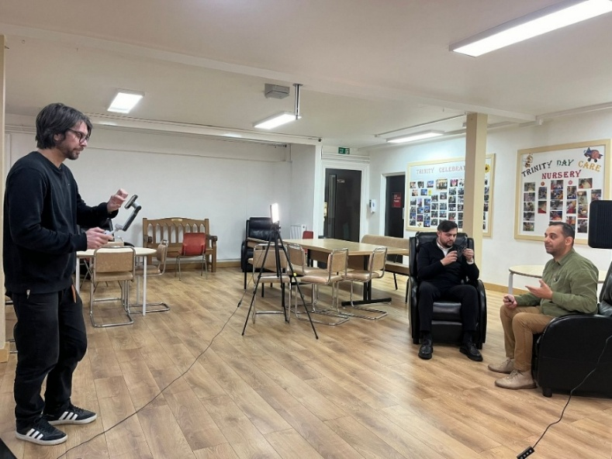
A clinical steering group, consisting of midwives, infant feeding specialists and academics, was recruited to sense test the video scripts for medical accuracy. Videos were translated into Polish, Romanian and Czech Romanes.

Behind the scenes of FFT’s ‘How to support your partner with baby feeding’ video

Outcomes
- A total of 29 Travellers were involved in the co-design and co-creation of these resources, consisting of Irish Travellers, Romany Gypsies and Roma individuals.
- A webinar was held to showcase the videos and posters and to explain the co-production process, with over 440 attendees.
- Resources launched on TikTok, YouTube, Instagram, Facebook and, FFT’s and RSG’s website.
- Videos were translated into Polish, Romanian and Czech Romanes.
- Copies of the posters were sent to 19 locations across the UK to a mix of GP surgeries and hospitals.
- The videos were viewed over 12,000 times, with significant views on TikTok. Focus groups regularly tell us this is where they view health information.
- The most popular videos were: ‘Dads and partners’, ‘Where to find support for your nerves’ and ‘Help to manage your finances as a parent’.
- The webinar Q&A allowed for direct engagement with healthcare professionals, helping address specific queries, such as how Gypsy, Roma and Traveller people could perceive the use of, or donation to, milk banks.
- The videos meet Baby Friendly Initiative (BFI) standards and can be shared by all services who are BFI accredited.
Wider impacts
- The videos prompted conversations on social media around preferred feeding options. These conversations centred around the importance of choice when parents are infant feeding and the importance of having support. Videos were shared on FFT’s closed ‘Healthy Lives’ Facebook groups, comments included:
‘It all depends on the support and the mothers mental and physical state too. As long as the baby is healthy either way works.’
- These resources have been hosted on several different websites including Enfield council and North Central London Integrated Care Board (ICB).
- The webinar and resource launch prompted organisations and professionals to reach out for advice on how to make their services more inclusive, to discuss Gypsies’ and Travellers’ maternity and neonatal experiences, and future collaboration. Examples of organisations who reached out include Pregnancy Sickness Support, Birthrights, The Lullaby Trust, and NHS staff from a perinatal mental health service in Croydon.

Spotlight: From infant feeding resources to collective action
Representatives from the charity Make Birth Better attended the infant feeding webinar and reached out to FFT following this. A meeting was scheduled a few weeks later to discuss the maternal and neonatal inequalities present for many Gypsy, Roma and Travellers. Make Birth Better then invited FFT and RSG to a collaborative maternity working group, consisting of over 100 organisations, clinicians, academics and parent advocates. The group has met every few weeks since the Maternity and Neonatal Investigation was announced, to co-produce an evidence-based plan which outlines the issues within maternity and neonatal services and the recommendations that are urgently needed.

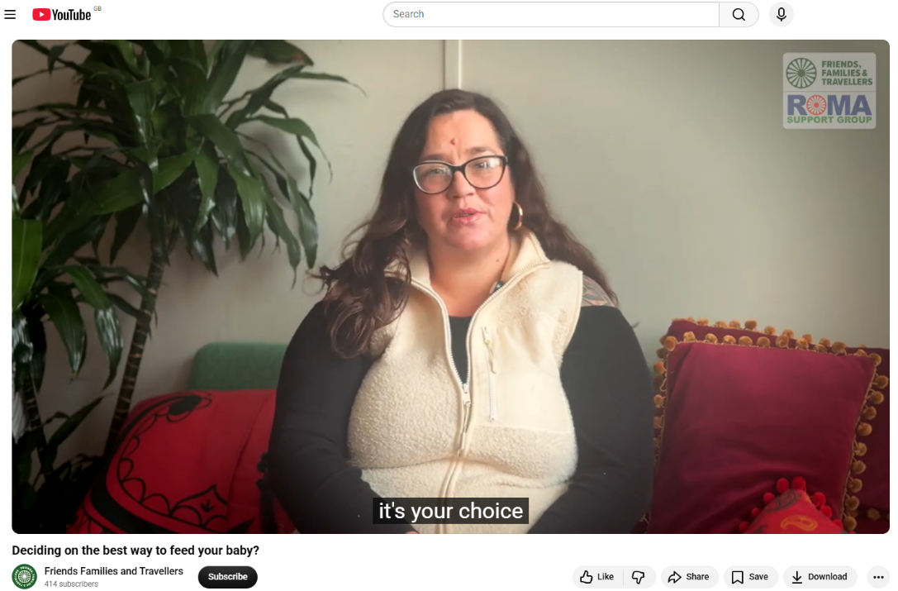
Having FFT and RSG involved ensured that despite often being overlooked in data, Gypsy, Roma and Travellers were named on the plan as a group who experience significant maternal inequalities and recommendations reflected this. This plan was submitted as evidence to the National Maternity and Neonatal Investigation. The working group, including FFT and RSG, attended a meeting with the Secretary for Health and Social Care, James Murray, and Baroness Amos in June to discuss the co-produced recommendations and how they can be meaningfully implemented. The Maternity and Neonatal Collective is now putting together a response to the National Maternity and Neonatal Investigation.

Infant Feeding Report
Overview
This research project aimed to:
- Identify infant feeding practices and cultural norms amongst people from Gypsy, Roma and Traveller communities.
- Identify experiences of infant feeding support and advice prior, during, and after birth.
- Produce and share a national report presenting main findings.
The project benefitted from oversight by a national NHS maternity policy lead, support from the Good Things Foundation, Maternity Action, Tommy’s and Sands Consortium and British Pregnancy Advisory Service. It involved direct contributions from 125 people from the Gypsy, Roma and Traveller communities (Romany Gypsy: 44, Roma: 40, Irish Traveller: 10, New Traveller: 16, Boater: 7, Scottish: 3, Showman: 2, Other: 11).

Outcomes
- resources were developed and circulated, including a summary report; full report; launch webinar recording and slides.
Longer term impact
- Presented the report at NHS Listening to VCSE Voices forum; NHS National Service User Voice Updates Call (Maternity and Neonatal Programme NHS England); SANDS Maternity Consortium Quarterly Meeting; and South Yorkshire Roma Interest Group.
- This project was supported by Lisa Ramsey (National Service User Voice Policy Lead of the Maternity and Neonatal Programme, NHS England), who facilitated opportunities for the findings of this report to be shared with wider maternity and neonatal teams and to inform future practice and policy developments in this area.

‘Tackling Maternal Health Inequalities in Gypsy, Roma and Traveller Communities’ report
Overview
Gypsy, Roma and Traveller communities face stark inequalities in maternal health outcomes, associated with major barriers to accessing care services, among other factors. With this in mind, FFT undertook this research project with the aim of producing guidance for professionals to improve knowledge and understanding of how to approach the planning and provision of maternity services for Gypsy Roma and Travellers and, to offer insights into the experiences of maternity for these groups. Guidance was informed by contributions from 91 Gypsy, Roma and Traveller people collected via surveys and focus groups (Romany Gypsy: 34, Irish Traveller: 24, Roma: 19, New Traveller: 42, Welsh Traveller: 1, Boater: 2, Other: 3), as well as anecdotal insights from the work of Friends, Families and Travellers and Roma Support Group.

The insights and voices of members of Gypsy, Roma and Traveller communities were prioritised in every stage of the research process, to ensure that the guidance authentically reflects experiences and needs.
Outcomes
- Summary and full guidance published and shared with over 150 professionals.
- This report launch bolstered our ongoing maternity/infant feeding work, with an increase in health-related inclusive services training requests, particularly relating to maternity care.
Longer term impact
- A London Regional Maternity Team video titled ‘Embracing communities: collaborating for better maternity care’, featuring two FFT team members, was shortlisted for a Royal College of Medicine Award.
- Presentation to the Race Equality Engagement Group (at the Cabinet Office) with the findings of the report.
- FFT Lived Experience Lead invited to speak with Baroness Amos as part of the National Maternity and Neonatal Investigation and, subsequently invited to join the Health Equity Expert Reference Group which sits within the Maternity and Neonatal Taskforce.

Spotlight: The creation of local training resources following FFT’s maternity inequalities report
Brighton and Hove have three NHS healthcare roles (midwife, health visitor and school nurse) that specifically support Gypsy, Roma and Traveller communities and asylum seekers and refugees in the area. They attended the FFT’s maternity inequalities webinar launch and read our report. Following the recommendation made in the report: ‘Gypsy, Roma and Traveller inclusive services training should be mandatory within all health and social care services’, they decided to co-produce a training video for local healthcare professionals to ensure they are providing culturally sensitive care to Irish Travellers locally. The video was designed in collaboration with and featured Irish Travellers from the local Traveller site. It also featured the specialist health visitor discussing the barriers to healthcare and advice on working respectfully and sensitively with the local communities. This video is now a mandatory part of the training package that all Brighton and Hove student midwives and health visitors receive. It was circulated to all current health visitors, the local immunisation team and some neonatal nurses and doctors working in maternal health. It has also been shared with the local university who have advised they are showing it to third year student nurses, as they have a module on migrant and Gypsy, Roma and Traveller communities.

Experiences of Suicide in Gypsy, Roma and Traveller communities
Overview
This report builds on prior research that indicates Gypsies, Roma and Travellers experience disproportionate rates of suicide. The report aimed to explore participants’ experiences related to suicide and the impact this has on individuals, families and communities. It explores themes of discrimination, inequalities within mental health support and other public services, stigma around mental health and suicide, the criminalisation and loss of nomadism and other traditional ways of life, and economic exclusion.
This report relied on intimate insights from Gypsies and Travellers who had experienced the death of a friend or family member by suicide.
Outcomes
- Report published and viewed on FFT’s website (as of Feb ’26): 206 / 2,385 (summary report)

Longer term impact

- As a result of the report findings, FFT was invited to consult on academic research and to deliver bespoke training to three different organisations, as well as to consult on a training module. We were also invited to attend and present our findings at seven different national or local suicide prevention conferences and panels.
- Attended a National Suicide Prevention meeting regarding cluster suicides to share expertise from the report.
- Attended a West Sussex suicide cluster panel to give expert advice.
- Attended two local suicide prevention conferences.
- Spoke at the Suicide Prevention Partnership Network and the National Suicide Prevention Alliance’s national conference.
- FFT were part of the Department of Health and Social Care’s Gypsy Roma and Traveller suicide prevention session.
- Consulted on a research project around the stigma of suicide in Gypsy Roma and Traveller communities led by York University and York Traveller Trust.
- Provided expert advice to the Independent Chair of Domestic Homicide and Suicide Review panels in Buckinghamshire.
- Provided training to suicide prevention organisations in Staffordshire and Stoke on Trent and to the national suicide charity, Harmless UK.
- Advised Harmless UK on including a module on Gypsies, Roma and Travellers in their own training programme.
- Delivered a workshop at Harm to Hope suicide prevention conference in Nottingham.

Guidance for Social Prescribing Link Workers on engaging with Gypsy, Roma and Traveller communities
Overview
This guidance for social prescribing link workers around support for Gypsy, Roma and Travellers was proposed in order to cover a gap in knowledge about the communities within the Social Prescribing system. It aimed to identify experiences and knowledge on both sides and help equip social prescribers with knowledge and resources to improve engagement.

This guidance developed is the first ever collation of information regarding Gypsy, Roma and Traveller people’s awareness and experiences of social prescribing services in the UK. Responding to one of the aims of the NHS Long Term Plan to develop the existing infrastructure of social prescribing, the objective of this guidance is to enable social prescribing link workers to effectively engage with and support members of Gypsy, Roma and Traveller communities and work towards reducing health inequalities.
Outcomes
- 4 resources developed: summary report; full report; launch webinar recording; slides.
- The project engaged 130 people from the Gypsy, Roma and Traveller communities, as well as 50 social prescribing professionals.

Longer term impact
- The project benefitted from support and input of a national NHS social prescribing policy lead, the London Social Prescribing network and around 50 social prescribing professionals. This consistent group of social prescribing professionals who directly engaged with the project now have a tool at their disposal to inform future policy development in this area.
- Presented findings at London Social Prescribing Network and Sussex Social Prescribing Network.
- The London Social Prescribing Network held a special webinar with Roma Support Group to discuss the issue of health inequalities among Gypsy, Roma, and Traveller communities. Following this, a resource page providing information on Gypsy, Roma and Traveller communities was created for the London Social Prescribing Network.

Enablers of digital inclusion in primary care for Gypsy, Roma and Traveller communities
Overview
‘The enablers of digital inclusion in primary care for Gypsy, Roma and Traveller communities’ research project aimed to identify and provide information to support the NHS, policy makers and primary care services to improve digital access for Gypsy, Roma and Traveller communities, by providing information to support service design and planning.

This project offered insights into the extent of digital exclusion experienced by Gypsy, Roma and Traveller people, as well as key enablers to support digital inclusion. It presents an overview of the general use of primary care services and extent of access to primary care services through digital means in these communities.
Outcomes
- 3 resources developed: full report; launch webinar recording; slides.
- 123 people from the Gypsy, Roma and Traveller communities involved in the research.

Longer term impact
- Findings informed Good Things Foundation’s seminar “Exploring the intersection between digital and health inequalities”.
- Findings presented to NHS app and NHS Online teams as part of 10 Year Plan Implementation. Expecting more consultation work onwards from this.
- Informed local initiatives in Brighton and Sussex, with FFT outreach workers working with PCNs to develop approaches to widen GP access.
- Presented findings to NHS England’s Primary Care Transformation team.
- Informed larger pieces of policy work such as our consultation and submission to the10 Year Plan.
- Through the All Party Parliamentary Group on Gypsies, Travellers and Roma, Baroness Whitaker raised a Parliamentary Question on what plans the Department of Health and Social Care had to improve access to primary care.

Tackling Mental Health Inequalities for Gypsy, Roma and Traveller people
Overview
‘Tackling Mental Health Inequalities for Gypsy Roma and Traveller people’ is guidance for mental health professionals supporting people in Gypsy, Roma and Traveller communities. It aims to improve knowledge of inequalities around accessing mental health services, improve understanding of how to approach mental health within Gypsy, Roma and Traveller communities from a healthcare perspective, and provides guidance on ensuring Gypsy, Roma and Traveller people are included in the planning and provision of mental health services.

Outcomes
- Full report published.
Longer term impact
- Collaborations with National Suicide Prevention Alliance (NSPA); FFT and RSG became members of the NSPA and findings from the report were presented to its members, as well as hosted on NSPA channels.
- Collaboration with Samaritans: RSG developed Roma-specific resources.

Improving Roma health: a guide for health and care professionals
Overview
This project, developed and delivered in collaboration with the Office for Health Improvement and Disparities (OHID), enabled development of a guide to help health and care professionals better understand health inequalities and barriers to accessing healthcare for Roma communities in the UK, take action to improve services and build a relationship with. The guide provides actionable suggestions for good practice, developed with partners in the VCSE Health and Wellbeing Alliance, and focuses on practical action for frontline health practitioners, team leaders and commissioners working with Roma communities.
Outcomes
- Guide produced and hosted on government website.
- References in Parliament discussions by Lord Greenhalgh.

Inclusion Health Audit Tool
Overview
The Inclusion Health Audit Tool project is a partnership of voluntary sector organisations delivering a new tool to help Primary Care Networks (PCNs) assess and improve their work with Inclusion Health groups, which include Gypsies, Roma and Travellers, who experience the most severe health inequalities in England. Supported by NHS England and NHS Improvement, the tool was co-produced with people with lived experience of health inequalities and representatives from PCNs. The tool enables PCNs to complete a short self-assessment against 22 Inclusion Health metrics in around ten minutes. PCNs that score highly can download and utilise as an Inclusion Health Quality Mark across their communications. After completing the assessment, PCNs receive a unique, tailored guidance pack to support embedding action on health inequalities into everyday practice.
The tool was developed in 2018 by Friends, Families and Travellers, Homeless Link, Doctors of the World, National Ugly Mugs and Stonewall Housing, working with PCNs, specialist organisations and inclusion health groups.

February 2024 saw NHS England release funding to support targeted outreach to GP surgeries, with any GP surgeries who had completed the audit tool receiving bespoke training from FFT.

Outcomes:
- Number of audits completed by health service organisations: 242
- Number of audits completed by PCNs: 507
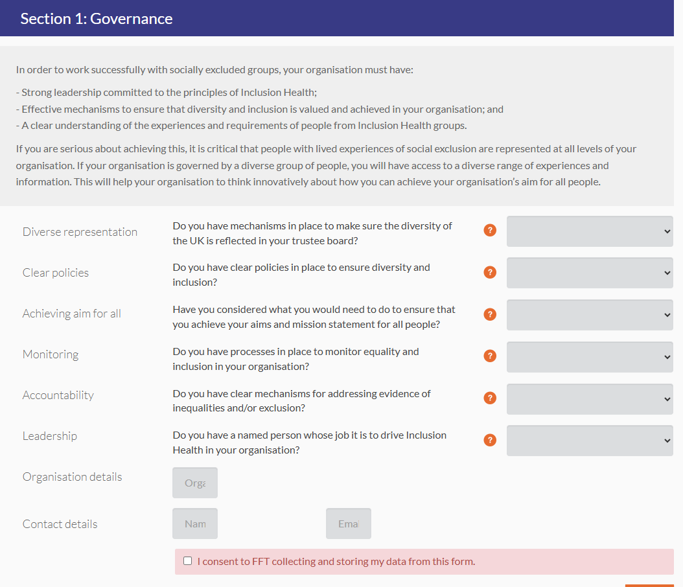
- Number of PCNs trained: 29 (850 GPs)
Section 1 of the Inclusion Health Audit tool

The Health Status of Liveaboard Boaters
Overview
‘The Health Status of Liveaboard Boaters’ project carried out a survey of Liveaboard Boater communities, exploring experiences of healthcare services and the barriers to accessing care. This was the largest initiative to record the self-reported healthcare experiences and status of Liveaboard Boaters.

Outcomes
- 356 Liveaboard Boaters surveyed
- Report produced and published
- Case studies were able to inform local and national work in making GPs more accessible for Boater communities: ‘I am a boater. I live permanently on board and travel the canals of England, trading antique China from Manchester to London… My mother died of uterine cancer after breast cancer… I have always been careful about breast lumps. In 2013 I found a lump in my right breast… I went to the local medical practice and tried to get help. In spite of the fact that I knew I had a right to register without an address, the receptionist and I think the practice manager told me categorically they wouldn’t register me. I persisted telling the person behind the desk I had a lump and needed to be seen, compromising my own confidentiality in order to get help. A practice nurse came out and altered the process by seeing me and referring me for a mammogram’.
- A participant of the project spoke at an NHS expo event in Manchester, detailing the barriers they faced when trying to access breast screening and subsequent cancer treatment as a person living nomadically.

Longer term impacts
- This report led to amended guidance on the government website on breast screening and the barriers to Gypsies, Roma and Travellers, especially for people with No Fixed Address status. The project informed recommendations such as ‘there must be simple processes for women to make or change appointments. Women can ask to be screened at an alternative service and services should accommodate these requests where possible.’

Professionals’ Survey

A major focus for the Gypsy, Roma and Traveller consortium has been recording and evaluating its impact this year. In August 2025, a survey was sent out to all professionals who attended a report or resource launch webinar over the last four years. Within this, participants were asked whether the webinars had changed their approach to working with Gypsy, Roma and Traveller people, whether the reports/resources have been used in their work, whether they have shared them and with whom, whether they have implemented recommendations detailed in the reports, and what further support they need.
Involvement: nearly 500 from Gypsy, Roma and Traveller communities involved in co-design of resources/research over four years.
Attendance: 1200 professionals attended webinars,
Total responses: 86 responses (42 fully completed, 44 partially completed)

‘I am more conscious now of the different terminologies people use to express mental health issues.’

‘I have found new ways to approach things which is always positive, to ensure that the people who need our support get it in the best way for them’

‘The publication by [FFT] has been referenced in our academic publications’

‘Infant feeding team have added links to our general resource channel’

‘I work to remind people that user insight focus does not have to be condition specific, it can be about the communities and cultures that people live and engage in.’

*Resources shared with over 6,000 people and 200 organisations*

‘Team training was shared with approximately 60 people over three localities.’

‘I sent the link on our closed Facebook page which has about 300 members.’

‘Shared in our newsletter, we put out monthly newsletters to over 4k supporters and stakeholders, and biweekly to 650 contacts representing over 200 VCSE sector members.’

‘We have added resources to our social spaces to be more inclusive.’

‘Using the research and recommendations' working each day with families.’

‘I have used the examples and recommendations to influence change in my broader work on ensuring social prescribing is inclusive.’

‘Gap analysis, currently scoping number of Traveller sites and plots in county- difficult to get information. Also difficult to get local stats.’

Case study from a professional, describing how they implemented a key recommendation in Staffordshire:

‘I work for Support Staffordshire who are the VCSE infrastructural Organisation for the County of Staffordshire and my role is a Community Development Team Leader for the Southwest of Staffordshire which is Cannock Chase, Stafford and South Staffordshire.
As part of the Healthy Communities Alliances in Staffordshire—of which there are three due to the size of the county—we maintain a shared Basecamp platform. This space provides all alliance members with access to resources, enabling the exchange of best practices, upcoming projects, research, and other relevant information.
Recently, I posted on Basecamp to gauge interest in forming a Community of Practice (CoP) focussed on the Gypsy, Roma, and Traveller communities. This initiative arose from repeated feedback that, while many organisations expressed a desire to engage with these communities, they often perceived it as too challenging, resulting in limited action. To date, the CoP has convened three times and now includes approximately 32 participants.
Staffordshire predominantly has an English Gypsy Traveller population, alongside Irish Travellers and an increasing number of Roma families. To strengthen relationships, I have visited a Housing Association Traveller site in Newcastle-under-Lyme with Healthwatch Staffordshire and engaged with residents.
Additionally, I have met with an individual who uses our Social Prescribing service to begin building trust and connections.
Our primary objective is to secure funding—ideally from the Integrated Care Board (ICB) and Public Health—to employ a Community Development Worker, preferably from within the GRT community. This role would focus on fostering relationships and establishing a VCSE organisation within Staffordshire and Stoke-on-Trent, ensuring that the voices of Gypsy, Roma, and Traveller communities are heard and represented.’

FFT was invited to attend a Community of Practice Meeting, where advice was shared on data/research gaps and available resources for Gypsies, Roma and Travellers. The group was connected with local community members and organisations to help progress plans to employ a Community Development Worker from within the communities.

Reactive Work (2025-2026)

Reactive work is additional work done by the HWA on behalf of government system partners, cascading information to Gypsy, Roma and Traveller communities, reviewing government policies, and consulting on future health planning. FFT and RSG have completed over 15 pieces of reactive work just this year, which include one-off consultations with system partners and longer-term collaborative work. This year’s reactive work has included involvement on the 10-Year Plan, the National Maternity and Neonatal Investigation, the unintended consequences of the government’s Covid-19 pandemic response, digital exclusion, cardiovascular diseases and, elective care waiting lists.

National Maternity and Neonatal Investigation: Family Panels and Call for Evidence

Through the HWA’s reactive work, FFT and RSG have been able to engage with the National Maternity and Neonatal Investigation (NMNI) in several different ways, including engaging with the NMNI’s family evidence panels as well as advising on accessibility and suitability of the panels for Gypsies, Roma and Travellers.

FFT was also asked to review the Call for Evidence (CfE), alongside other HWA and Maternity Consortium members. This resulted in a delay in the CfE being published, as it was heavily changed and simplified in line with FFT’s feedback. For people living outside of Sussex or those who did not wish to share their experiences in a group setting, FFT arranged to go through the CfE with them, offering the same renumeration as people attending the panels. FFT was then asked to host its own family evidence panels, which were co-designed through community steering groups.

Access to therapy through the NMNI
The NMNI have contracted a psychological support service, PAM, for participants of the investigation to access before, during or after they had given evidence. The service offers trauma therapies that are hard to access on the NHS such as Eye Movement Desensitisation Reprocessing (EMDR).
An FFT colleague, who is from the Gypsy, Roma or Traveller communities (redacted for confidentiality) and contributor to the evidence panels, contacted PAM’s service to find out what was available and how to sign up. This helped test run the accessibility and appropriateness of the service.
The colleague identified potential issues which were fed back to the NMNI team, such as a PAM call handler not knowing what the Maternity Investigation was. This was fed back to PAM to improve accessibility for participants of the NMNI. This also helped identify some aspects of the service which risked causing distress to community members, potentially causing disengagement or erosion of trust in the service or therapist. For example, PAM asks for next of kin contact details during the assessment for therapy, which could be worrisome for community members; that confidential information is shared with their next of kin or that having therapy leads to the belief they are struggling to look after their children, and therefore the service must notify their next of kin.
The colleague was able to explain to participants that asking for next of kin details is a standard practice across healthcare and only used in emergencies.
FFT called participants of the family evidence panels, preparing them for the process of accessing the service. Due to mistrust towards statutory services, there can be low levels of trust in Gypsy, Roma and Traveller communities towards professionals, and this was an effective way of mitigating this. It supported participants of the NMNI, who are likely to experience significant barriers when accessing mental health services, to access specialist trauma therapies in a few weeks from signing up.
Number of panels hosted by FFT & RSG | 4
Number of participants at panels | 23
Number of participants completing the Call for Evidence | 6
Number of participants signed up to PAM for therapy | 10

Inclusion Health Subgroup

FFT and RSG are members of the Inclusion Health Subgroup within the HWA. The subgroup is composed of organisations with expertise in specific areas related to inclusion health. The primary aim of the subgroup is to address health inequalities faced by inclusion health groups by amplifying community voices, facilitating co-produced solutions and supporting a two-way flow of information between inclusion health groups, VCSE organisations and national policy leads in health and social care.

OHID’s SPOTLIGHT Tool
Overview
The Spotlight tool is a public data sharing platform, developed by the Office for Health Inclusion and Disparities (OHID), which presents key statistics related to the public health outcomes of inclusion health groups. This work included direct engagement with HWA members through the Inclusion Health Subgroup, a Project Steering Group formed of HWA and non-HWA inclusion health group representatives, and a series of interviews with Gypsies, Roma and Travellers, individuals from refugee and migrant backgrounds, people with experience of the criminal justice system, sex workers, and LGBTQIA+ individuals.
Outcomes
- Support provided to OHID team to ensure Gypsy, Roma and Traveller peoples lived experience was included in the development of the SPOTLIGHT tool.
- The publication of a report.
Longer term impact
- RSG and FFT referenced in the Inclusion health data and intelligence resource for England developed by OHID, NHS and UKHSA to complement the SPOTLIGHT tool.

‘Health and healthcare among Travellers’, Pahl & Vaile (2009).
‘Discrimination against childbearing Romani women in maternity care in Europe: a mixed-method systemic review’, Watson & Downe (2017).
‘Tackling Suicide Inequalities in Gypsy and Traveller Communities’, Friends, Families and Travellers (2022).
‘All Ireland Traveller Health Study’, All Ireland Traveller Health Study Team (2010).

