Friends Families and Travellers and Gypsy and Traveller Empowerment Hertfordshire written information for the examination of the UK State party's report to the 66th Cycle of the United Nations Committee Against Torture
Victoria Stallwood | Submitted to the United Nations on 22nd March 2019, published 3rd May 2019
The following submission addresses issue number 43 of the ‘List of issues prior to submission of the sixth periodic report of the United Kingdom of Great Britain and Northern Ireland’ in relation to Gypsy, Roma and Traveller (GRT) communities, which asked:
“What measures have been taken to combat hate crimes, including crimes committed on the basis of race, nationality and religion? Please comment on reports of a rise in Islamophobic and anti-Semitic hate crimes. Please provide information on the specific measures taken to address underreporting of disability and transgender-motivated hate crimes.”
List of Issues Prior to Reporting Number 43, Article 16, UN Committee Against Torture, 2016
Key Issues
- 44% of British adults openly express ‘negative’ attitudes toward Gypsies, Roma and Travellers, the most of any protected characteristic group in England.
- Police officers consider hate crime to be the most common issue Gypsies, Roma and Travellers report to them, but less than 15% of hate incidences are reported to police.
- Gypsy, Roma and Traveller communities are largely overlooked in key sections of the Hate Crime Action Plan, in particular, the section on prevention.
- The UK government fails not only to address high levels of anti-Gypsyism in the media but actively invests in advertising in some of the worst media outlets for this.
- The UK government repeatedly fails to treat and try racially motivated hate crimes/incidents against Gypsy, Roma and Traveller communities as hate crimes/incidents.
Introduction
High levels of discrimination against Gypsy, Roma and Traveller communities in the UK is well documented. Although Gypsy and Traveller populations have been present in England since before the 16th century and well before the 19th century respectively, they have not always been recognised as ethnic groups. It was established through case law in 1989 that Romani Gypsies are a distinct ethnic minority with a long shared history, a common geographical origin and a cultural tradition of their own (CRE v Dutton). It was not until 2000 that Irish Travellers were also established as an ethnic group through case law (O’ Leary v Allied Domecq).
The Equality and Human Rights Commission published a research report in 2018 which explored prejudice in Britain with 2,853 adult participants. When asked about their views of Gypsy, Roma and Traveller communities, they found that 44% of British adults openly expressed ‘negative’ attitudes toward Gypsies, Roma and Travellers, the most of any protected characteristic group in the study (EHRC, 2018a). Prejudice against these groups in the UK has been described as the last acceptable form of racism. In this report, we outline data on the prevalence and nature of hate incidents against Gypsy, Roma and Traveller communities, details of how the government is trying (but largely failing) to address hate against Gypsy, Roma and Traveller communities and information on the role the media plays in inciting hatred against Gypsy, Roma and Traveller communities. We will also share case studies on hate crimes/incidents against Gypsy, Roma and Traveller communities in England.
Gypsy, Roma and Traveller hate related incidents
In the absence of any centrally collected government data on Gypsy, Roma and Traveller hate related incidents, third sector organisations working with Gypsy, Roma and Traveller communities have begun to collect information on the prevalence of race hate incidents/crimes and obstacles to reporting it. In 2017, the Traveller Movement carried out a survey of 199 Gypsy, Roma and Traveller people in the UK and found that 77% had experienced hate speech or hate crime (Traveller Movement, 2017). Furthermore, in their ‘Policing by Consent’ report released in 2018, the Traveller Movement found that police officers they spoke to from 45 territorial police forces in England, Scotland and Wales considered hate crime to be the most common issue members of Gypsy, Roma and Traveller communities report to the police (Traveller Movement, 2018).
This is especially startling when you take into account data collected by GATE Herts which has found that Gypsy, Roma and Traveller communities report less than 15% per cent of hate incidences to the police (Gate Herts, 2018). GATE Herts have been commissioned by the Ministry of Housing, Communities and Local Government to develop an online hate crime/incident reporting service called ‘Report Racism GRT’ which is specifically for Gypsy, Roma and Traveller communities in order to encourage hate crime reporting and address the lack of national data. As part of this project GATE Herts also trained the local police force in Gypsy, Roma and Traveller cultural awareness and hate speech/crime guidelines.
To date, the ‘Report Racism GRT’ tool has received over 691 reports since its launch in July 2016. Incidents have been grouped into seven categories;

As part of the process of reporting a hate incident on the ‘Report Racism GRT’ website, people are asked if they have reported the issue to the police and if they haven’t, why they chose not to. Out of the 441 people who answered this question, only 57 people said that they also reported the incident to the police. A number of reasons were given for this:

“If I reported everything I came across I would do nothing else… I have tried to report and respond to the abuse which is often targeted at our animals and children but there is too many and you just can’t win”
Respondent to GATE Herts Research
This project provides sorely needed data on hate crimes and incidents committed against Gypsy, Roma and Traveller communities. However, it is vital that the Government begins to collect disaggregated data on hate crime which can begin to give us a fuller picture of who is experiencing hate crime in England and what the outcomes are for victims when reported. In particular, if certain geographic areas have higher prevalence of hate crime or specific events spark surges in hate crime, the Government can begin to take a preventative approach to address this. This will enable the Government to more effectively target the causes of hate and to more adequately safeguard the lives of those most at risk.

UK strategy to address hate crime
The UK government have ratified the Convention Against Torture which, under Article 16 states that, “Each State Party shall undertake to prevent in any territory under its jurisdiction other acts of cruel, inhuman or degrading treatment or punishment which do not amount to torture as defined in article I”. However, the devolution of the political system in the UK has meant that the Government place responsibility on individual local authorities, police forces and other statutory bodies to fulfil broad national recommendations. This then results in unclear lines of accountability and a lack of overall strategic leadership which is fundamental to enable the UK to effectively comply with the Convention against Torture and other international treaties.
In 2016, the Home Office devised a Hate Crime Action Plan (HCAP) which set out a four year programme covering five themes:
- Preventing hate crime by challenging beliefs and attitudes
- Responding to hate crime within our communities
- Increasing the reporting of hate crime
- Improving support for victims of hate crime
- Building our understanding of hate crime
In 2017/18, there were 94,098 hate crime offences recorded by the police in England and Wales, an increase of 17% on the previous year. Of the total number of hate crime offences, 76% were racially motivated (Home Office, 2018). We believe that this rise reflects both improvements in hate crime reporting and an actual increase in incidents of hate crime. However, since the HCAP’s inception, clear improvements have been made in some areas of tackling hate crime for communities in the UK more generally, but despite the high evidenced need to address prejudice against Gypsy, Roma and Traveller communities this is often overlooked and under resourced. For example:
- Although it is widely acknowledged and evidenced that Gypsy, Roma and Traveller children are at high risk of racist bullying, the HCAP makes no commitment to address this, nor have commissioned any projects to do so (Equality and Human Rights Commission, 2018).
- The government have established Cross-Government Working Groups on Antisemitism and Anti-Muslim hatred. Although the research from the Equality and Human Rights Commission is clear that Gypsy, Roma and Traveller communities experience the highest levels of hate in England, no such Cross-Government Working Group has been established.
The HCAP recognises that Gypsy, Roma and Traveller communities are at risk of hate incidents and/or crimes and the Government have provided some funding to third sector organisations to support hate crime reporting in Gypsy, Roma and Traveller communities. However, on the national level, the Home Office statistical bulletin for Hate Crime in England and Wales for 2017/18 presents aggregated ethnicity data for racially motivated hate crimes with five ethnicity categories but no data on hate crimes committed against Gypsy, Roma and Traveller people. This means that it is difficult to build an understanding of hate crime against Gypsy, Roma and Traveller people and to respond to hate crime as outlined in the government HCAP.
Hate in the media
Local and national media coverage of Gypsy, Roma and Traveller communities is almost universally negative. It tends to play upon ideas of criminality and focuses on issues around unauthorised encampments or crime. The low standard of reporting on Gypsy, Roma and Traveller communities has normalised bigotry and intolerance against these groups within society. Repeatedly, we hear reports from members of Gypsy, Roma and Traveller communities who say that the media is a key player in promoting hatred against Gypsies, Roma and Travellers. Almost daily, we see reports in the press which contain inaccuracies about Gypsy, Roma and Traveller communities and stories which actively discriminate against these communities.
The Equality and Human Rights Commission, in its 2016 report (see references), outlined numerous examples where members of the UK media used prejudicial or pejorative references, or promoted bias, racism and stereotyping. Whilst safeguarding freedom of speech, it is vital that steps are taken to promote more balance within the media. Existing mechanisms for challenging discrimination in the media through the Independent Press Standards Organisation (IPSO) are ineffective and lengthy. The discrimination clause in IPSO’s Editors’ Code of Practice is ineffective in tackling most forms of discrimination and even where a breach of the code does take place, the process for addressing this is so lengthy that millions of people are able to read an article before it is amended or taken down.
It is therefore critical that the UK government take a new and more effective approach to addressing anti-Gypsyism in the media.
Examples of headlines promoting hate in UK newspapers:
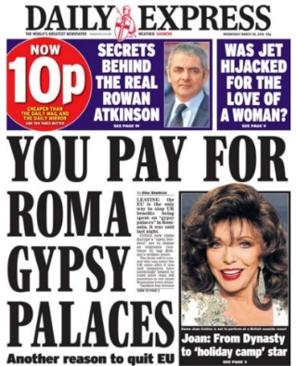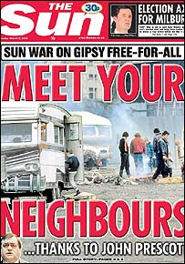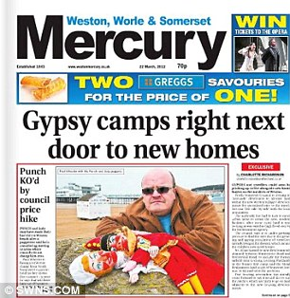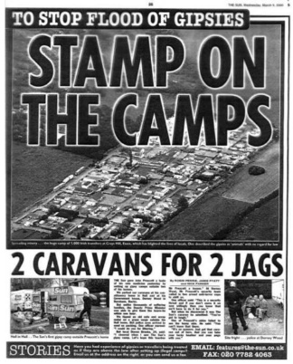
Stories which promote hate and intolerance are almost universally accompanied by a comments section which creates a forum for people from the general public to express hateful views against Gypsy, Roma and Traveller communities. There is usually a correlation between the sentiment in an article and the degree of hatred expressed in the comments. We regularly see comments which call for people to set fire to Travellers’ caravans, which use racist language and which call for Genocide or the return of Hitler. Here you can find examples of comments found under an article published online about unauthorised encampments on Cambridge News on 26th March 2018:
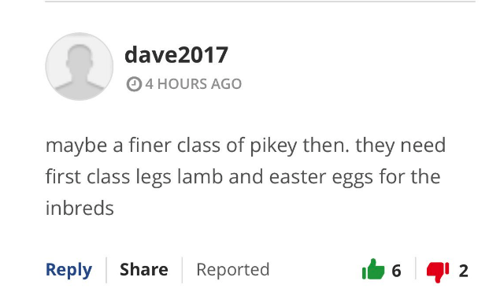
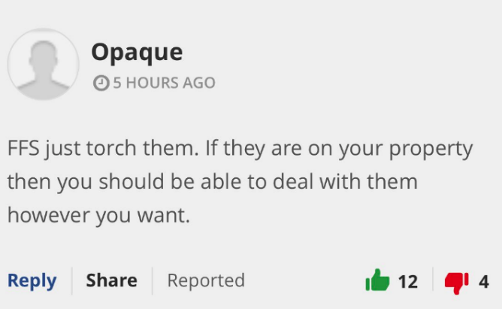
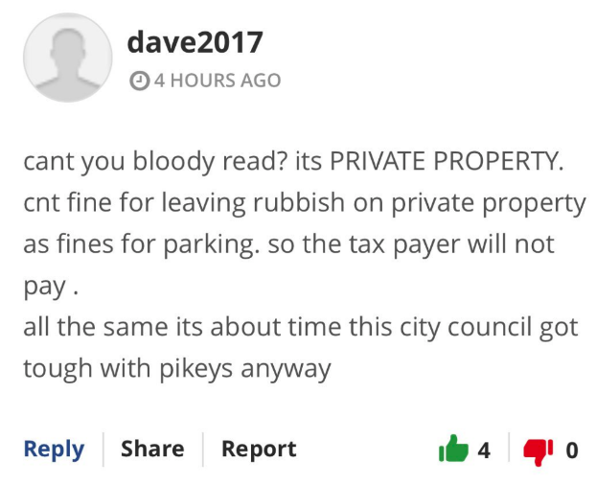
Sadly, threats such as “torch the caravans” are not always empty. Earlier this week, on Monday 18th March in Melton Mowbray, seven caravans were set alight on a Traveller site in a hate related incident. This has received limited and delayed coverage in the press and at the time of writing, senior government officials have yet to speak out in condemnation. However, in the early hours of yesterday morning, Thursday the 21st March, five Mosques in Birmingham had their windows smashed in. There was widespread coverage in the press and senior officials within government were rightfully outspoken in condemning the attacks. This suggests an unacceptable level of tolerance of hate crimes perpetuated against Gypsy, Roma and Traveller communities. It is vital that senior officials in the government are vocal in condemning incidents such as the Melton Mowbray caravan arsons.
The UK government is complicit in the promotion of hate through the media not only because of its failure to effectively regulate it but because it actively invests in advertising in the newspapers who have created such hate-filled and pejorative narratives. Speaking about The Sun newspaper’s ‘Stamp on the Camps’ campaign against homeless Gypsies and Travellers, Mike Jempson, Director of MediaWise said, “I've not seen anything like this since the Julius Streicher Nazi campaign against Jews”. Despite this, a parliamentary question tabled by Stephen Doughty MP in 2016 revealed that government departments spent over £800,000 on advertising in the Sun alone in 2015/16.
To illustrate the issue, here is an example highlighted by ‘Stop Funding Hate’ of Government advertising in the Express newspaper in February 2017, next to a headline which promotes hate-filled stereotypes about Muslim communities:

In 2018, the UK government signed up to the UN Global Compact for Safe, Orderly and Regular Migration which contains a commitment from all signatories to stop, “allocation of public funding or material support to media outlets that systematically promote intolerance, xenophobia, racism and other forms of discrimination towards migrants, in full respect for the freedom of the media.” However, since signing the Global Compact on Migration, the UK government has continued to invest in newspapers which promote racism and other forms of discrimination towards migrants, including Roma communities.
It is clear that by maintaining the status quo, the Government is not making vital progress in preventing and addressing hate crime. The HCAP progress report (2018) states that the Government plans to continue working with “the Society of Editors, the Media Trust and the Independent Press Standards Organisation to update the ‘Reporting Diversity’ booklet.” However, the vast majority of civil society actors can see that this is highly unlikely to bring about the change we need to see.
If the Government are to continue with this plan of action, given the level of racial incitement against Gypsy, Roma and Traveller communities in the press, at the very least, the HCAP should specifically include actions against anti-Gypsyism in their work with the media and other allied organisations.

Gypsy and Traveller hate crime case studies
Online step-by-step instructions to set alight Traveller caravans, October 2018
The Sun published an article about a series of German language anti-Gypsy posters in Sussex. In the comments section, a reader claimed to have previously set fire to someone's house and car, then gave step-by-step instructions on how to set Gypsies’ caravans alight when they were asleep, without getting caught by the police. They gave 'pro tips' which included: "do not drive your car to caravan park, either take a bike or borrow someone else vehicle plate, "if you put gas in a can, make sure you do it a few weeks earlier out of town so they don’t just rewind the CCTV for the past 2 days and catch you", "the caravan's fuel tank is at the back of the vehicle, so make sure you have that part drenched."
We reported the incident to police and were advised that the police had not been able to identify the person so they would be closing the case. When asked for more details on what investigation actually took place, it appeared that no actions had actually been undertaken. Only when pressed by activists was the investigation re-opened and the police force in question tried to track down the IP address and were able to identify that the post was written by someone in the USA. No action was taken.
Barry Smith murder case October 2014
Mr Smith, an English Gypsy 43 year old man was discovered outside Kilburn Welfare Social Club, Chapel Street, on the morning of October 6th 2014 by local dog walkers. He had been beaten to death using pool cues and a fence post and his body had been set alight. Police investigating the crime described it as a particularly horrific crime scene. The family believed this was a racially motivated crime, yet it was not tried as hate crime and therefore the sentences were lighter. Three suspects were eventually convicted of murder.
Jonny Delaney murder case May 2003
Jonny Delaney, who was 15 year old and from the Irish Traveller community was kicked to death by two teenage boys. Johnny's father Patrick Delaney and the detective who led the investigation into the death said they believed it was a racist attack. One of the defendants had stamped on Johnny's head with both feet and said he deserved it because "he was only a... Gypsy". Chester Crown Court heard the fight had started after one of the gang of youths shouted a racist comment at Johnny's group, but the judge ruled the attack was not racially-motivated, again resulting in a lighter sentence.
Shotgun attack in 2001 on Romani Gypsies in Bramdean
There was a shotgun attack on Romani Gypsies in Bramdean, near Winchester, in June 2001. There were no injuries, however two vehicles were damaged by pellets from two separate cartridges. This was the second attack against the Gypsy site on Bramdean Common. Fifteen months previously, four shotgun cartridges were fired at two caravans as families slept inside. Investigating police felt that this may have been a racially motivated attack (Donnelly, 2002).

Abusive neighbours
A vulnerable homeless family were being supported by our outreach team. The mother was pregnant and one of the older children in care. They went from emergency B & B accommodation to housing. Neighbours in the new house were seriously racially abusive towards the family shouting “Pikey” and smearing excrement on their door. The family were supported to report the crime to the police and victim support.
August 2017- 200 local residents confront 20 Travellers
A group of 20 Travellers, including children, who had no place to stop their caravans stopped on Baytree Recreational Ground in Weston-super-Mare. Following discussions on social media, hundreds of local residents crowded around the caravans chanting, “out, out, out” and did not leave until threatened with arrest.
The Home Office (2016:37-38) says “A hate crime/incident is any criminal offence/non-crime incident which is perceived, by the victim or any other person, to be motivated by a hostility or prejudice based on a person’s race or perceived race.” However, in many of these shocking cases, crimes were not treated nor tried as hate incidents or crimes, yet all the victims and families of victims reported perceptions of racial motivation. This highlights clear inadequacies in the criminal justice system to effectively address hate crime against Gypsy, Roma and Traveller communities.
Conclusion
In summary, the Committee Against Torture’s asked, “What measures have been taken to combat hate crimes, including crimes committed on the basis of race, nationality and religion?” We believe that the UK government, despite robust evidence on the prevalence of prejudice and hate crimes against Gypsy, Roma and Traveller communities have failed to take proportionate measures to address this both in their Hate Crime Action Plan and in their day-to-day practices in supporting victims of hate crime to access justice.
We note that despite the fact that Article 16 on the Convention Against Torture states that, “Each State Party shall undertake to prevent in any territory under its jurisdiction other acts of cruel, inhuman or degrading treatment or punishment which do not amount to torture as defined in article I” the UK Government have failed to prevent acts of cruel, inhuman and degrading against Gypsy, Roma and Traveller communities. This is based on the fact that despite evidence from the Equality and Human Rights Commission which substantiates that Gypsy, Roma and Traveller communities experience more prejudice than any other group in the UK population, these communities are almost invisible in the government’s Hate Crime Action Plan.
We consider the continuation of the UK Government’s in investment in press outlets promoting anti-Gypsyism to contradict both the consensus and spirit established through the UN Global Compact for Migration.

Recommendations
- The UK Government should ensure all police forces disaggregate their hate crime data using the 18+1 ethnic monitoring system, including Gypsies, Roma and Travellers.
- The Home Office should include disaggregated data on hate crimes against Gypsy, Roma and Traveller communities in the Crime Survey for England and Wales.
- The UK Government should review the Hate Crime Action Plan to include action on anti-Gypsyism in every section, with a focus on prevention in the media and in schools.
- The UK Government should stop allocating public funds to media outlets which promote racism, in line with commitments made in the UN Global Compact for Migration.
- The UK Government should set up and resource a Cross-Government Working Group on anti-Gypsyism.

About us
Friends Families and Travellers
Friends, Families and Travellers (FFT) is a leading national charity that works on behalf of all Gypsies, Roma and Travellers regardless of ethnicity, culture or background.
Contact
fft@gypsy-traveller.org | www.gypsy-traveller.org | Twitter: @GypsyTravellers | Facebook: @FriendsFamiliesandTravellers | +44 (0) 1273 234 777
Gypsy and Traveller Empowerment Hertfordshire
Gypsy and Traveller Empowerment Hertfordshire (GATE Herts) is a Community-led organisation, which seeks to educate both travelling communities and the wider population to live side by side in a diverse society.
Contact
info@gateherts.org.uk | www.gateherts.org.uk | Facebook: @gate.hertfordshire | +44 (0) 1992 289 056
References
Donnelly, E. (2002) Hate Crimes Against Travellers. Criminal Justice Matters, vol. 48, no. 1, pp. 24-25. https://www.crimeandjustice.org.uk/sites/crimeandjustice.org.uk/files/09627250208553449.pdf
Equality and Human Rights Commission (2016) England’s most disadvantaged groups: Gypsies, Roma and Travellers. Available at - https://www.equalityhumanrights.com/sites/default/files/is-england-fairer-2016-most-disadvantaged-groups-gypsies-travellers-roma.pdf [5.3.19]
Equality and Human Rights Commission (2018a) Developing a national barometer of prejudice and discrimination in Britain Available at - https://www.equalityhumanrights.com/sites/default/files/national-barometer-of-prejudice-and-discrimination-in-britain.pdf [Accessed: 45.3.19]
Equality and Human Rights Commission (2018b) Is Britain fairer? Available at - https://www.equalityhumanrights.com/sites/default/files/is-britain-fairer-2018-pre-lay.pdf [Accessed 29.10.18)
European Union Agency for Fundamental Rights (2018) Fundamental Rights Report. Available at - https://fra.europa.eu/en/publications-and-resources/publications/annual-reports/fundamental-rights-2018 [Accessed 1.11.18]
Gate Herts (2018) Recognise, report, resolve. Available at http://www.gateherts.org.uk/wp-content/uploads/2018/06/Recognise-Report-Resolve.pdf [Accessed: 26.10.18]
Hacked Off and The Media Diversity Institute. Open Letter: The industry press body IPSO is failing to protect minorities from press discrimination. 28th February 2019. Available at - https://mediadiversified.org/2019/02/28/open-letter-the-industry-press-body-ipso-is-failing-to-protect-minorities-from-press-discrimination/ [Accessed 6.3.19]
Home Office (2016) Action Against Hate: The UK Government’s plan for tackling hate crime. Available at - https://assets.publishing.service.gov.uk/government/uploads/system/uploads/attachment_data/file/543679/Action_Against_Hate_-_UK_Government_s_Plan_to_Tackle_Hate_Crime_2016.pdf [Accessed 30.10.18]
Home Office (2018) Action Against Hate: The UK Government’s plan for tackling hate crime – ‘two years on’. Available at - https://assets.publishing.service.gov.uk/government/uploads/system/uploads/attachment_data/file/748175/Hate_crime_refresh_2018_FINAL_WEB.PDF [Accessed 26.10.18]
Home Office (2017) Hate Crime, England and Wales, 2016/17. Available at - https://assets.publishing.service.gov.uk/government/uploads/system/uploads/attachment_data/file/652136/hate-crime-1617-hosb1717.pdf [Accessed: 26.10.18]
Independent Press Standards Organisation (2018) Editors Code of Practice. Available at - https://www.ipso.co.uk/editors-code-of-practice/ [Accessed 2.11.18]
Traveller Movement (2018) Policing by consent: Understanding and improving relations between Gypsies, Roma, Travellers and the police.
Abrams, D. Swift, H. and Houston, D (2018) Equality and Human Rights Commission: Developing a national barometer of prejudice and discrimination in Britain. Available at - https://www.equalityhumanrights.com/sites/default/files/national-barometer-of-prejudice-and-discrimination-in-britain.pdf [Accessed: 26.10.18]

