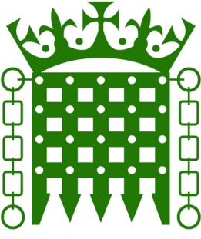
HOUSE OF COMMONS

Chloe Smith MP
Minister for Constitution
Cabinet Office

By email

8 November 2018

Dear Chloe
Following publication of the government’s response to the Women and Equalities Committee inquiry into the Race Disparity Audit, we wanted to write to follow up on our very useful meeting with you earlier this year when we discussed ethnic monitoring for Gypsy, Traveller and Roma communities.
We are pleased to read the positive response regarding the Cabinet Office’s intention to work with the Office for National Statistics to support the widespread adoption of the 18+1 ethnicity classification across government departments (and any consequent changes to the Census). We also note that the government response recognises that ‘Departments currently collect ethnicity data in many different ways, the RDU will continue its work with Departments to enhance the consistency of ethnic classifications of data collected and include on the website.’ We would be extremely grateful if you could provide us with more information on how the government will take steps to advance this, with our particular interest being data collection for Gypsy, Traveller and Roma communities, disaggregated for the separate communities as far as possible, and visibility of that data on the Ethnicity Facts and Figures website.
In our correspondence witj you in May, we explained the need for three separate ethnicity boxes for Romany Gypsy, Irish Traveller and Roma for the 2021 Census. Would you be able to update on how your discussions with ONS on this matter have progressed since our meeting?
We were also interested to hear of the ‘Quality Improvement Plan’. This sounds very promising, particularly in relation to the goal to “Increase data robustness, by combining data for a few years, to enable better estimates for smaller ethnic minority groups; by exploring what steps might be taken to reduce levels of non-reporting; and by exploring the feasibility of ‘ethnic minority boosts’ of existing surveys.” We are keen to hear more about how Gypsy, Traveller and Roma ethnic monitoring will be incorporated into the Quality Improvement Plan.
Yours sincerely

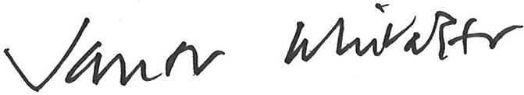

Baroness Janet Whitaker and Kate Green MP
Co-Chairs, All-Party Parliamentary Group for Gypsies, Travellers and Roma

