GYPSY & TRAVELLER SEMINAR
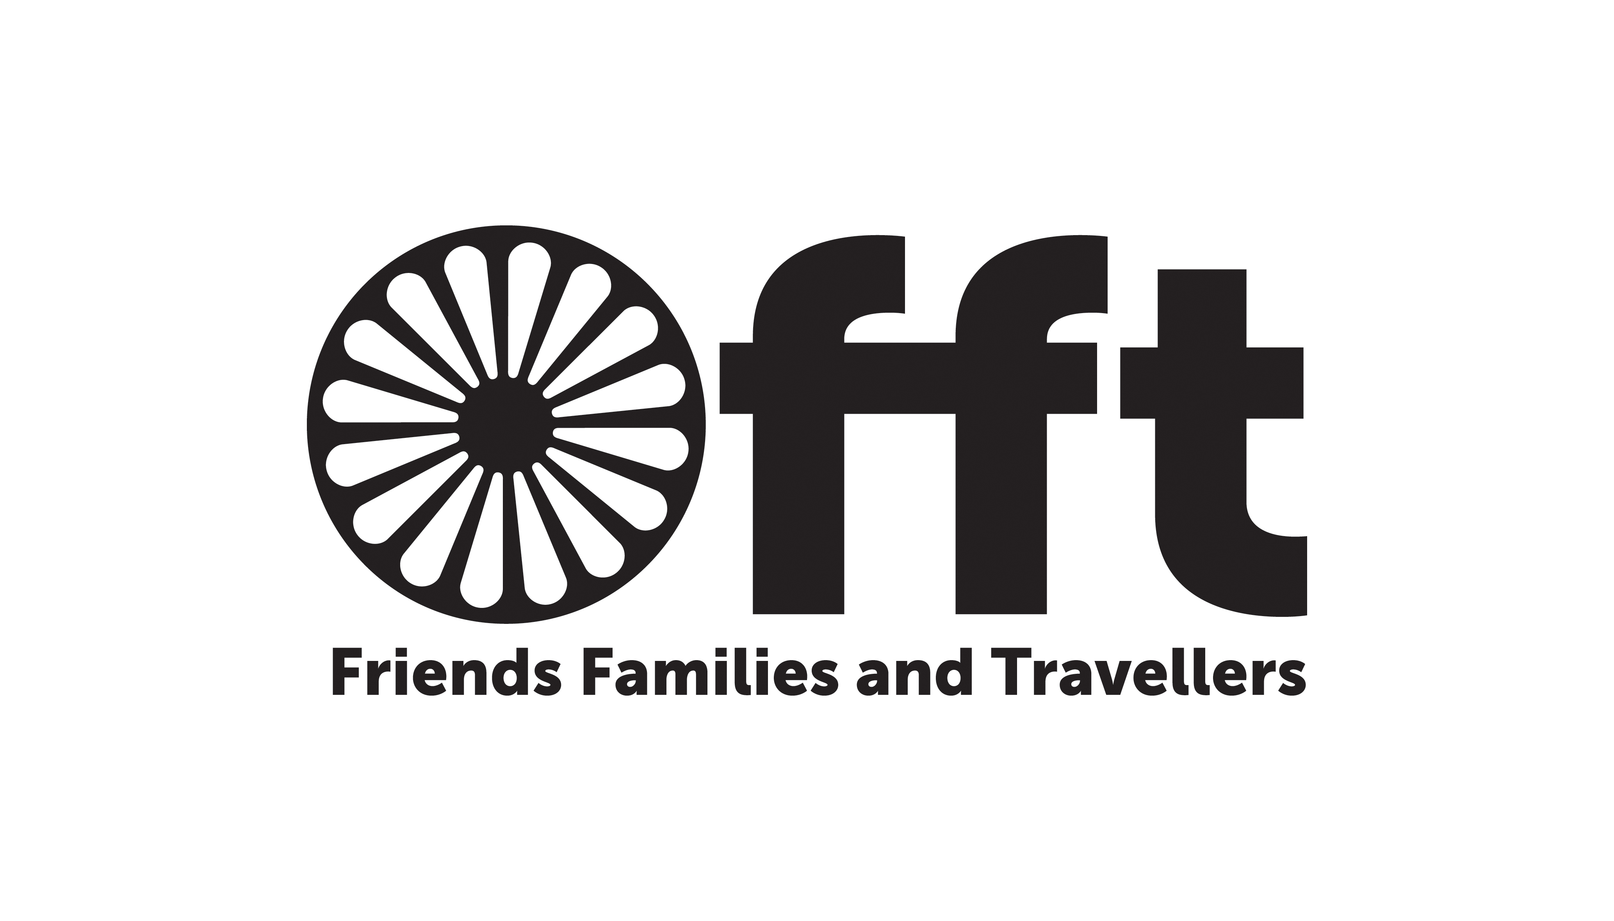
Thursday 29th September 2016
Community Base, 113 Queens Road
Brighton BN1 3XG

BOOKING FORM

FEES
£50 per delegate

HOW TO REGISTER

EMAIL this form to:
sarah@gypsy-traveller.org
FAX this form to 01273 234778
POST this form to:
Friends, Families & Travellers
Community Base
113 Queens Road
Brighton, BN1 3XG

PLEASE ADDRESS ANY ENQUIRIES BY EMAIL TO: sarah@gypsy-traveller.org
or phone Sarah Mann on 01273 234803

PAYMENT
Please select payment type.
An invoice will be issued.

□ BY CHEQUE:
Please make cheques payable to:
Friends, Families & Travellers

□ BY BACS: CAF Bank Ltd
Friends, Families & Travellers,
Sort Code: 40-52- 40
Account No. 00014537

□ BY INVOICE (please fill in address for invoice opposite)

PURCHASE ORDER No.……………………

1. Name of delegate:

………………………………………........
Role Title:

…………………………………………….
Email:……………………………………..

2. Name of delegate:

………………………………………........
Role Title

…………………………………………….
Email:……………………………………..

3. Name of delegate:

………………………………………........
Role Title

………………………………………........
Email:……………………………………..

Name of organisation to invoice:

………………………………………………
Address:
………………………………………………
………………………………………………………………………………………………………………………………………………………………………………………………

Telephone…………………………………

