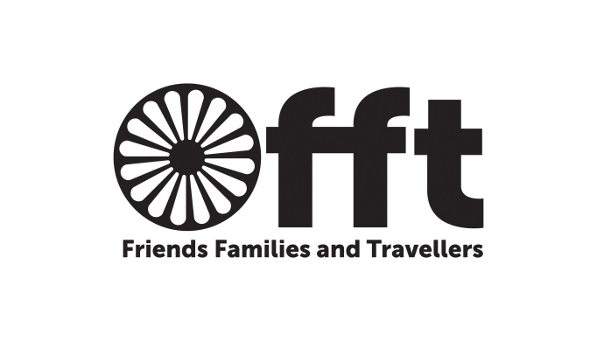

Friends Families and Travellers
Is a charity who seek to end racism and discrimination against Gypsies, Travellers and Roma, whatever their ethnicity, culture or background, whether settled or mobile, and to protect the right to pursue a nomadic way of life.
We work on campaigning, case work, and capacity building to help Gypsy and Traveller groups help themselves and mainstream organisations to work better with Gypsies and Travellers.
BACKGROUND
As part of FFT’s ongoing commitment to the support and development of Travellers, the new internship programme seeks to increase the professional skills and competences of individual Travellers towards securing paid professional employment and/ or improved educational attainment through the provision of fully supported internships, based at the charity’s workplace in Brighton.
Internships will be on a rolling programme funded by the Paul Hamlyn Fund within FFT until 2018. Details of intern opportunities and how to apply will be posted on the charity’s website and Facebook page from time to time. FFT aims to ensure that interns’ work is diverse and fulfilling.
Who Can Apply?
Travellers aged over 18 (or otherwise discussed with the Management Committee), who are literate and who wish to develop experience and skills toward professional employment in the third sector and elsewhere or are seeking development toward further educational attainment are encouraged to apply. Interns may be undergraduates, graduates, students in or seeking third level education. Adult Travellers seeking to develop or return to a professional career may also apply.
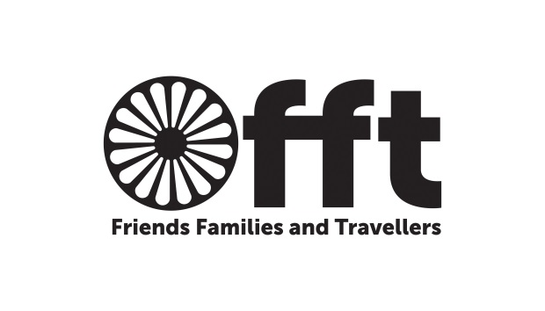

Interns will undertake a mixed role within the charity. Interns will identify their own needs and aspirations so they can develop their skills and experience. Interns will assist with the recruitment of other young people as FFT volunteers as well as assisting other staff with areas of work that of interest to them e.g. finance and administration; project or group development; social media; policy for example health. Routine administration is expected of all FFT personnel.
Length of Internships
Internships with FFT are offered for a period of 3 months. It is possible for internships to be extended for a second and third term of three months. However this cannot exceed twelve months
Days & Hours
Interns are expected to work agreed number of hours per day, in accordance with office opening hours and terms and conditions stated in the internship agreement. The current organisational limit for all internships is 14-16 hours per week.
Stipend
Interns are paid a fixed sum of money, agreed upon at the beginning of internship agreement. The stipend is paid in monthly instalments throughout the internship agreement and will equate to an hourly rate of £7.85 per hour.
Expenses
Reasonable travel costs to attend external meetings and events related to their internship will be reimbursed. Expense claims are submitted at the end of each month they are incurred to the Finance Officer.
Mentoring support
Interns will be supported by Liz MacPherson, the Paul Hamlyn Project Officer who will provide advice, guidance and support.

Monthly meetings
Monthly meetings will take place with interns and their mentor to: review progress reports, plan tasks for month ahead, identify skills developed and training gaps etc.

Work Plans
Work plans are drawn up by interns and mentors at the beginning of the internship to clearly identify goals, actions, timescales etc. Work plans should be reviewed every three months between interns and mentors.
Progress Reports
Progress reports are written by interns on a monthly basis and submitted to mentors on an agreed date at the end of each month.
Training
Training for interns is an important part of their work experience. As much as possible free or in-house training opportunities will be looked for. Interns are encouraged to research training opportunities suited to their learning goals and to negotiate the feasibility of these with mentors.
Peer Support
Interns are encouraged to support each other in their work by getting together to share good practise and discuss issues that may arise during the work. An intern could be nominated to raise issues or queries from the perspective of the interns with the organisation either in team meetings during the intern feedback slot or separately.
Post internship work
Interns will be encouraged to use the internship as a way of developing their CVs, and will receive a reference on completion of internship.
FFT’s Internship programme is being funded by the Paul Hamlyn Foundation until 2018. The internship is unlikely to provide a direct route to (full time) employment at FFT.
For further information, contact FFT on 01273 234864
or email: liz@gypsy-traveller.org
For further information about FFT visit our website:
www.gypsy-traveller.org

.

